CSA0613-Design and Analysis of Algorithms
CO2-AT2
Student Name: A. Bhavya(192424417)
Question 3
A hospital database stores patient records in an unsorted list because records are frequently added and updated. Doctors need to quickly search for patient details during emergencies.
Problem Analysis
The hospital database stores patient records in an unsorted list because records are frequently added and updated. During emergencies, doctors need to retrieve patient information quickly. Sequential search examines each record one by one until the required patient record is found. This method is suitable because it works efficiently with unsorted data and does not require additional sorting operations.
Working of Sequential Search
- Start searching from the first record.
- Compare the patient ID with the target ID.
- If the IDs match, return the patient details.
- Otherwise, move to the next record.
- Continue until the record is found or the list ends.
- If no match is found, display "Patient record not found".
Example
Patient records:
[101, 105, 103, 109, 107]
Search patient ID:
109
Search process:
101 → Not found
105 → Not found
103 → Not found
109 → Found

Algorithm for Sequential Search
Step 1: Start.
Step 2: Read the patient records.
Step 3: Read the patient ID to search.
Step 4: Start from the first element.
Step 5: Compare each patient ID.
Step 6: If a match is found, display the patient details.
Step 7: Otherwise, move to the next record.
Step 8: If all records are checked and no match is found, display "Record not found".
Step 9: Stop.
CODE:
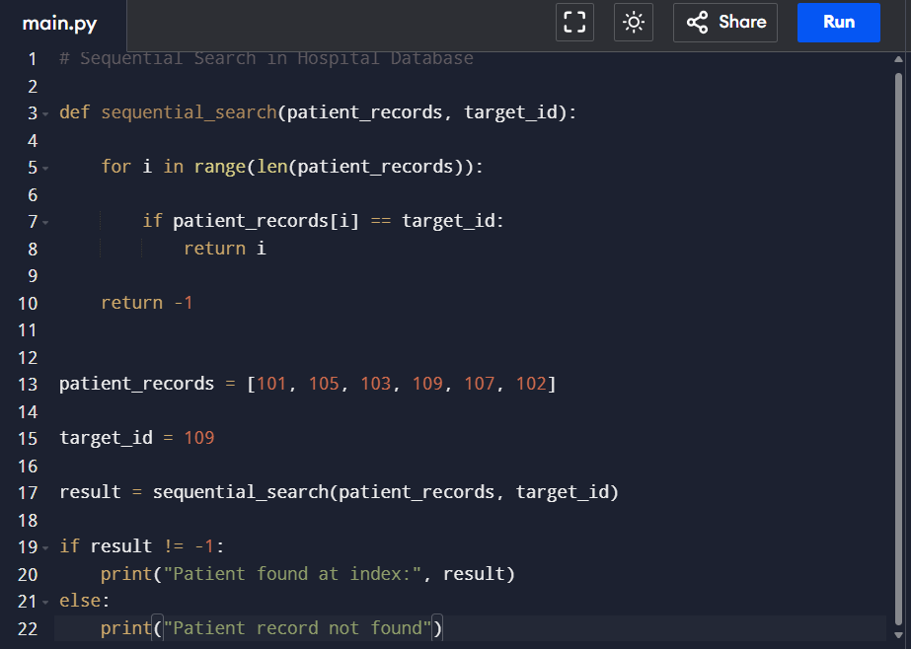

OUTPUT:
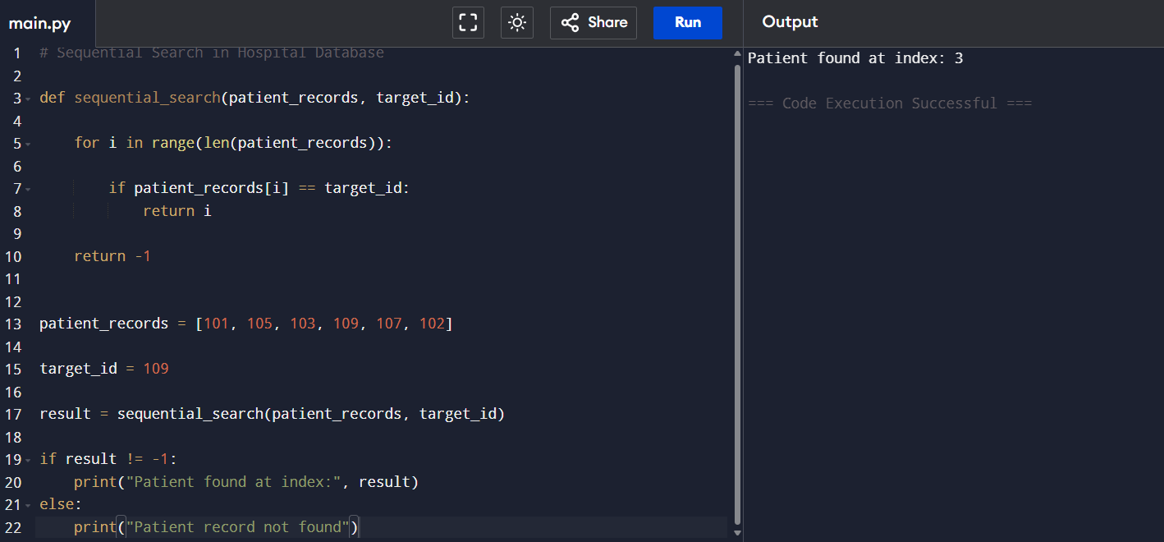
Best Case
The patient record is found at the first position.
Example:
[109, 101, 105, 103]
Only one comparison is required.
Time Complexity
O(1)
Average Case
The patient record is found somewhere in the middle of the list.
Example:
[101, 105, 109, 103]
Approximately n/2 comparisons are needed.
Time Complexity
O(n)
Worst Case
The patient record is at the last position or not found.
Example:
[101, 105, 103, 107, 109]
All records must be checked.
Time Complexity
O(n)
Space Complexity
O(1)
Sorting is not preferred because:
- Patient records are frequently added.
- Existing records are updated regularly.
- Sorting after every update increases execution time.
- Emergency systems require fast insertion.
- Sorting large databases consumes more memory and processing time.
- Sequential search works efficiently on unsorted data.
Advantages
- Easy to implement.
- Works with unsorted data.
- No additional memory is required.
- Supports frequent insertions.
- Suitable for small databases.
Limitations
- Slow for very large datasets.
- Checks records one by one.
- Requires more time in the worst case.
- Not efficient for repeated searches.
Conclusion
Sequential search is suitable for hospital databases because records are frequently added and updated. It does not require sorting and works directly on unsorted data. Although its worst-case time complexity is O(n), it is useful in situations where data changes frequently.

